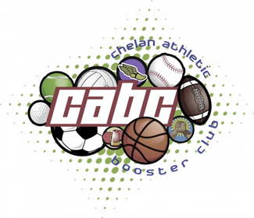
16TH Annual Golf Tournament

Sunday, September 11th 2022
~at~
Bear Mountain Ranch Golf Resort
1050 Bear Mountain Ranch Rd
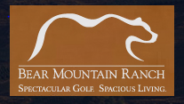
Team check in @ 8am
Shotgun Start @ 9am

Cost to play (two options):
- $110.00 individual player
- $500.00 Corporate Sponsorship
(team of 4 plus hole sponsorship)
Player fee includes green fees, cart rental, range balls and sack lunch**
Hole Sponsorship Only:
$200
***This does not include membership fee to CABC***
To pre-register for the tournament or for further information please call Amber Finch at 509-433-8493 or email amberfinch5@gmail.com
All proceeds help fund our community youth activities.

